Aws EC2 Instance

1.Create an executable jar file of the spring boot project in eclipse

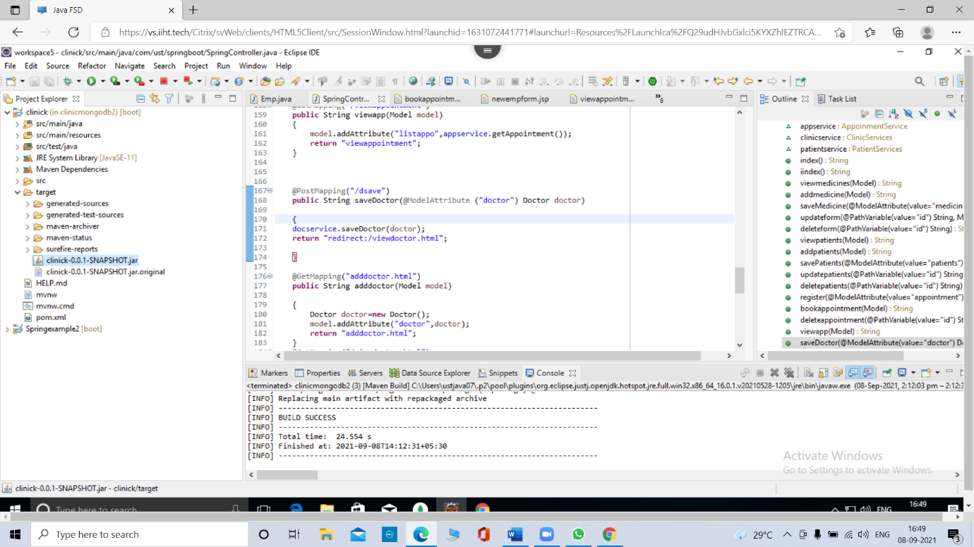

2. Go to the **services** and click on **s3**

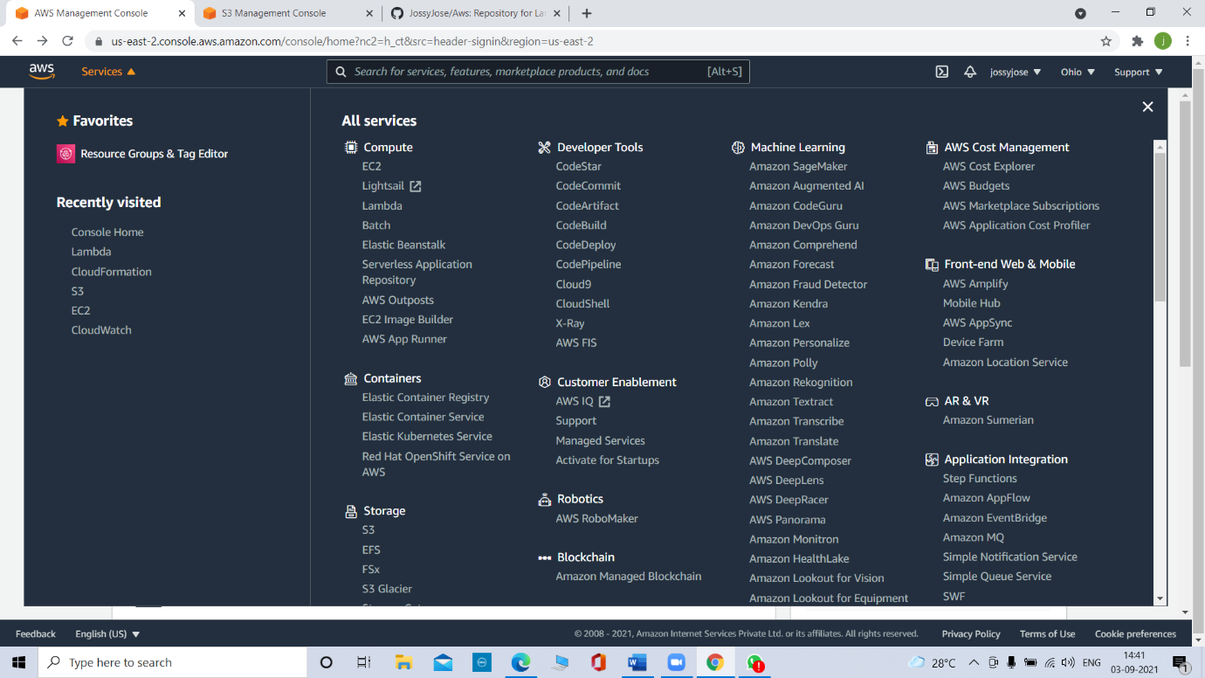

2.1. Create a s3 bucket

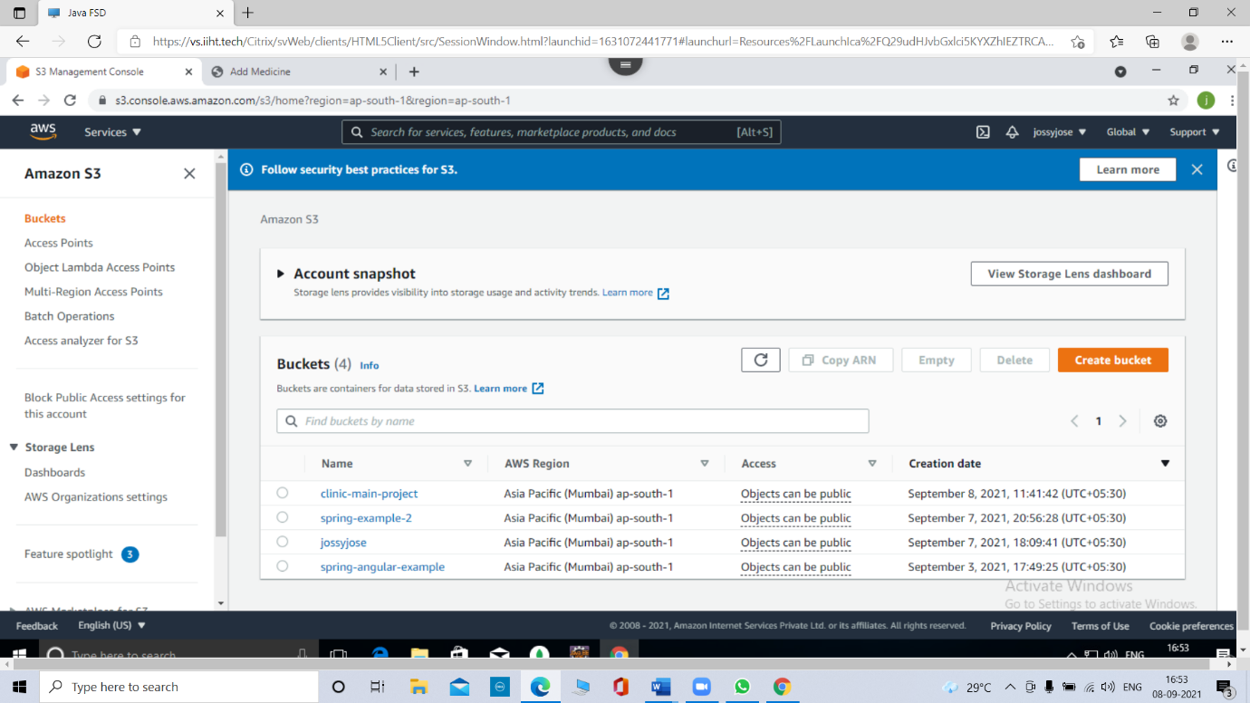

2.2. Drag and drop or upload the jar file of the project into the s3 bucket

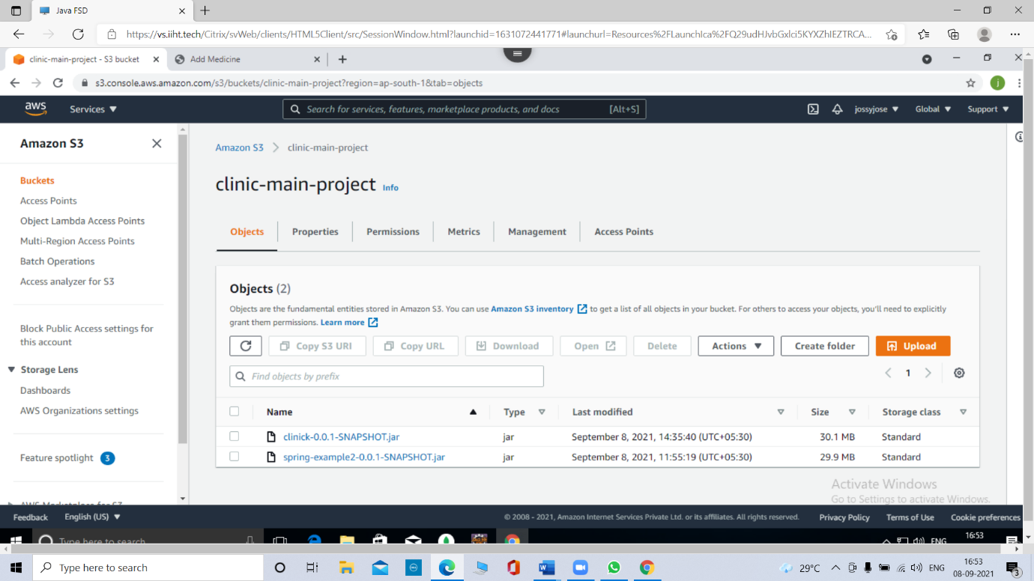

3. Go to **Services** and click on **EC2**. Launch an EC2 instance

3.1. Click on **Launch instance**.

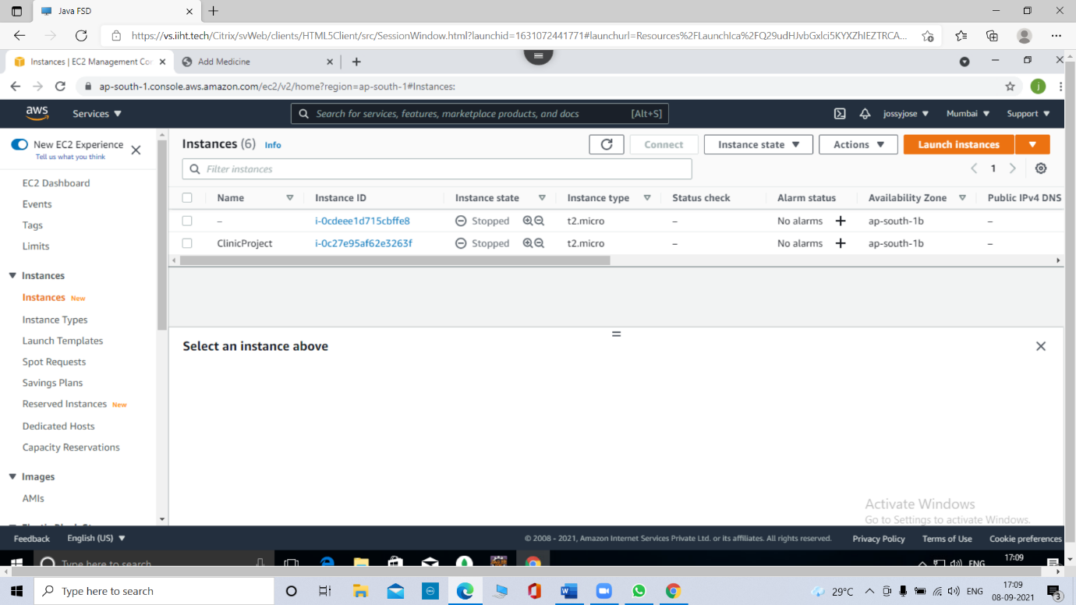

3.2. Select **Ubuntu 18.4** AMI

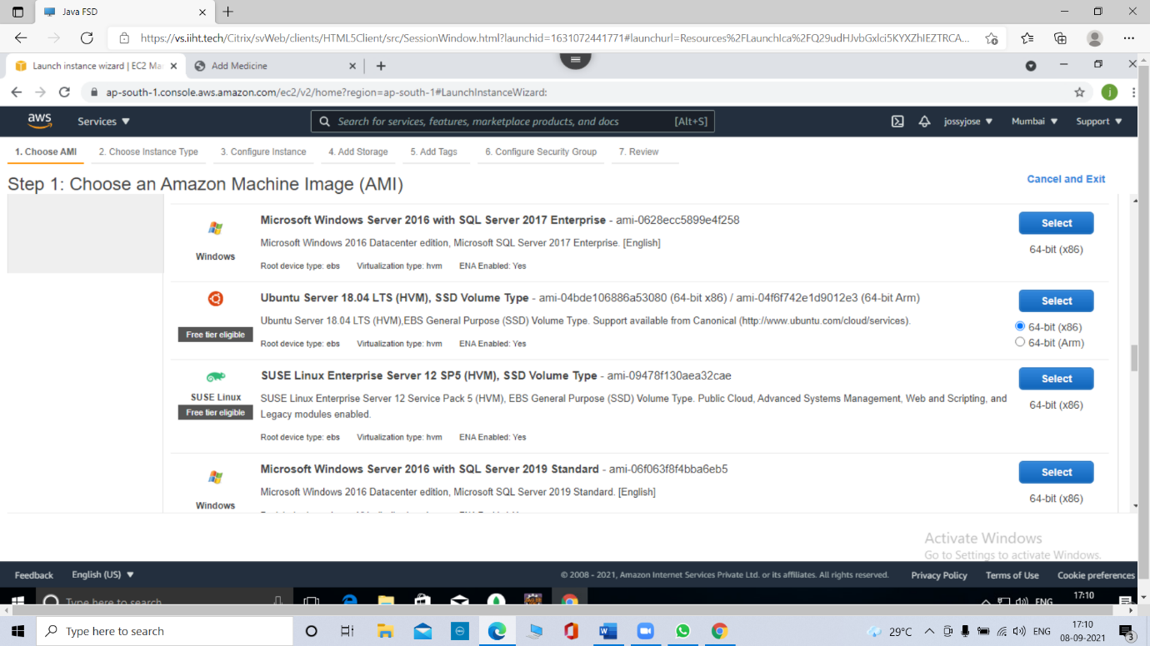

3.4. Add all the ports that we needed for the running of project by click on **Add rule**

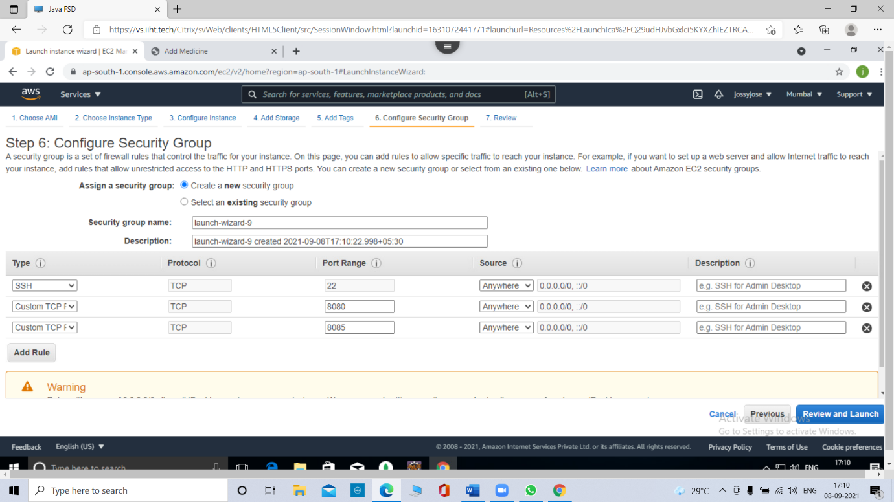

3.5. create a new key pair and download the key pair.

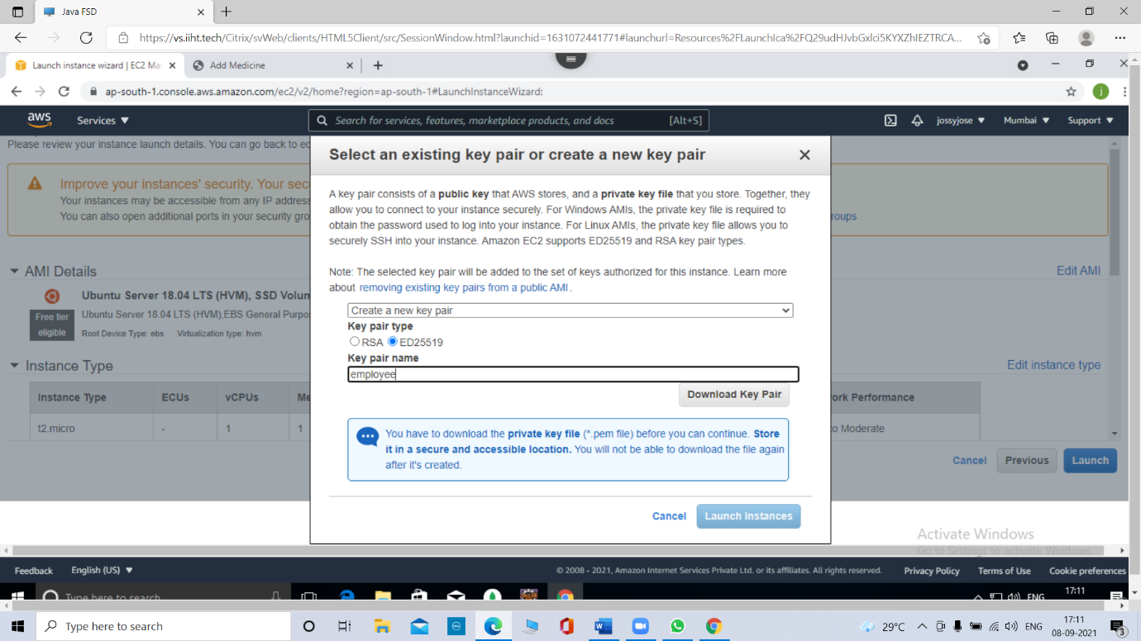

3.6. Launch the instance.



4. Download **putty** from **putty.org** and install it**.**

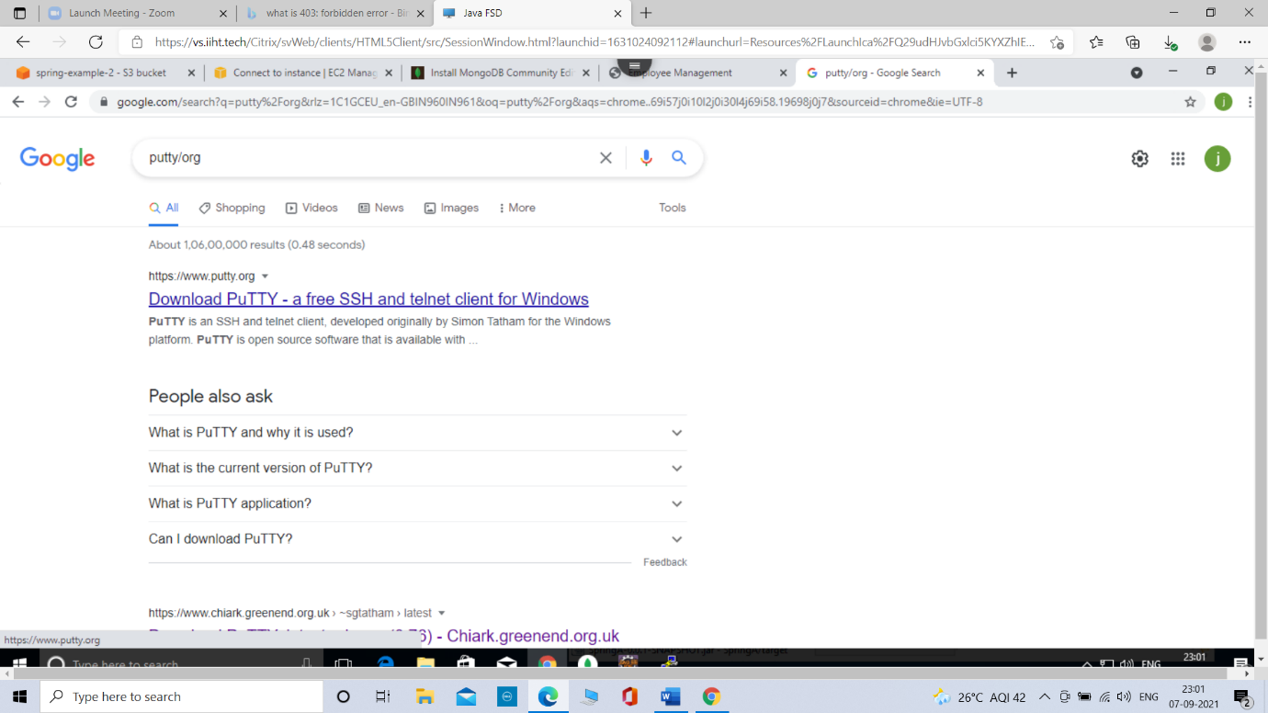

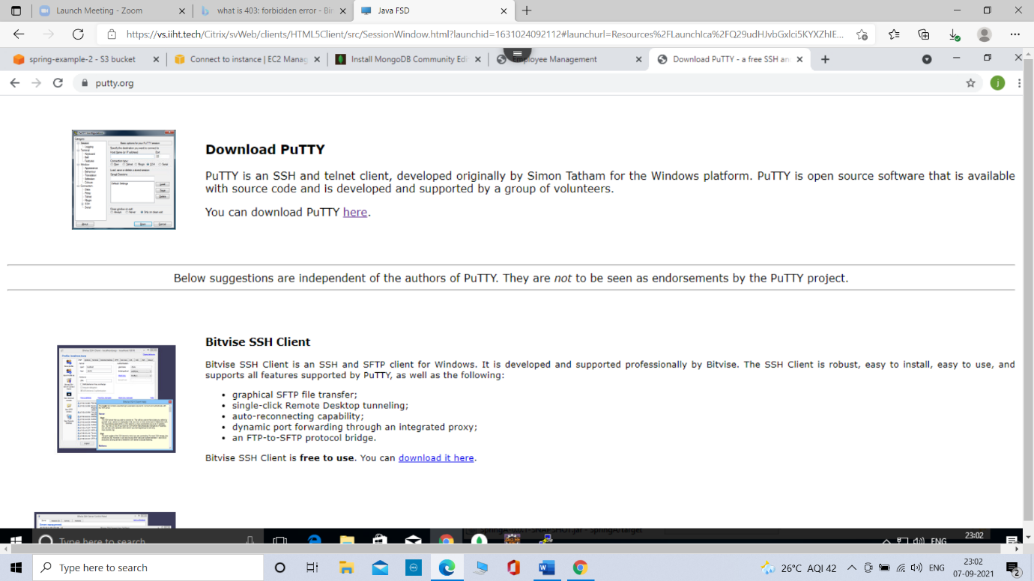

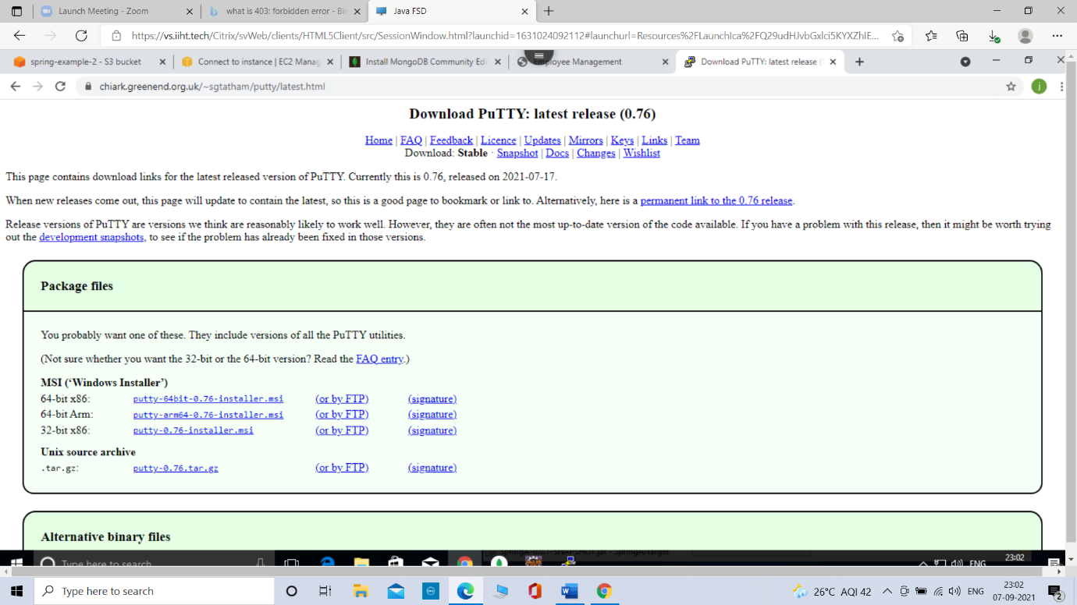

4.1. Take **puttygen** from windows.

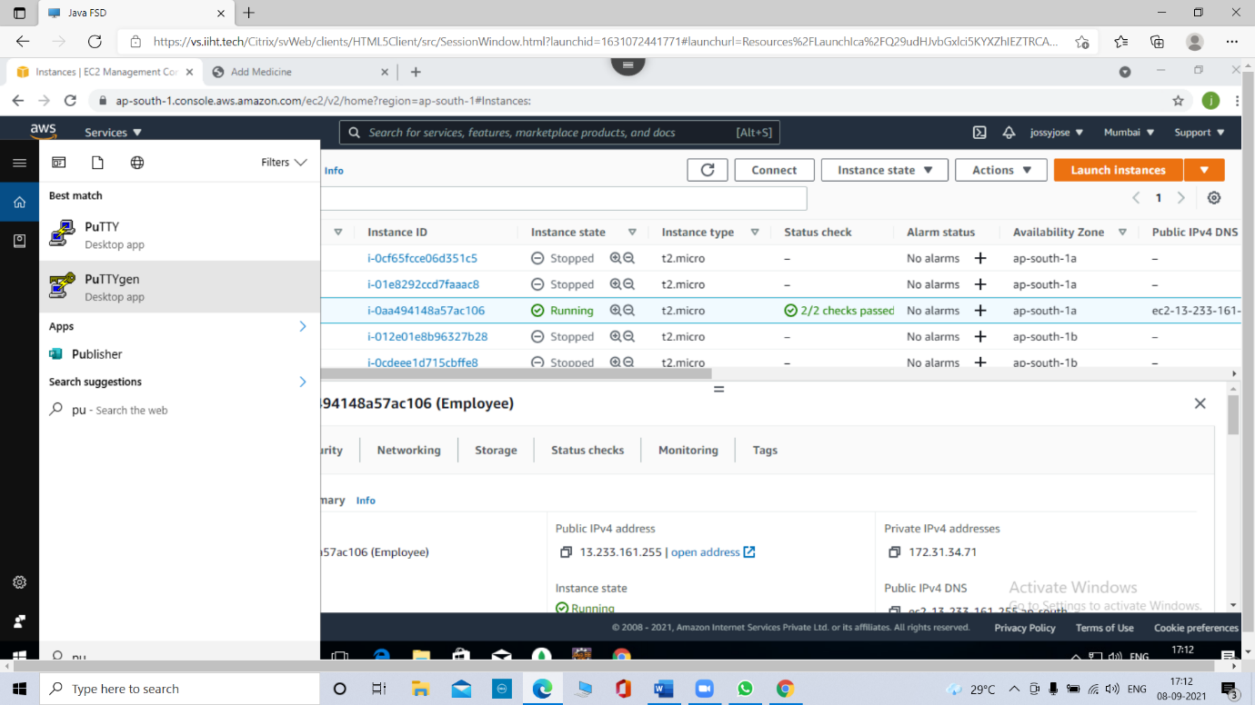

4.2. Click on **Load** and select the **.pem** file(Dowloaded new key pair or private key). Then click in **open**

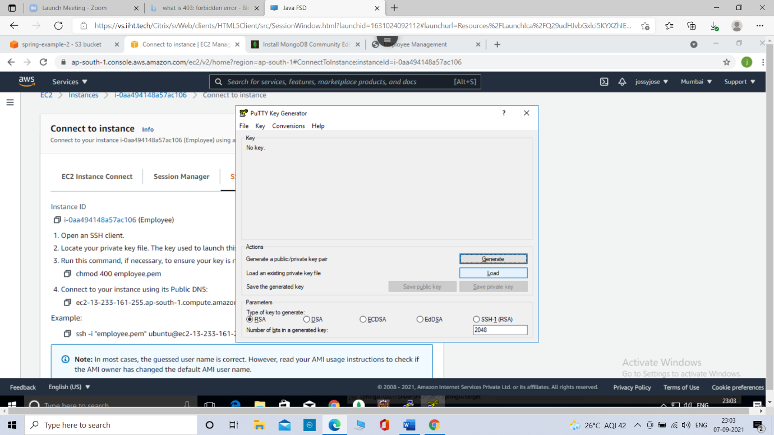

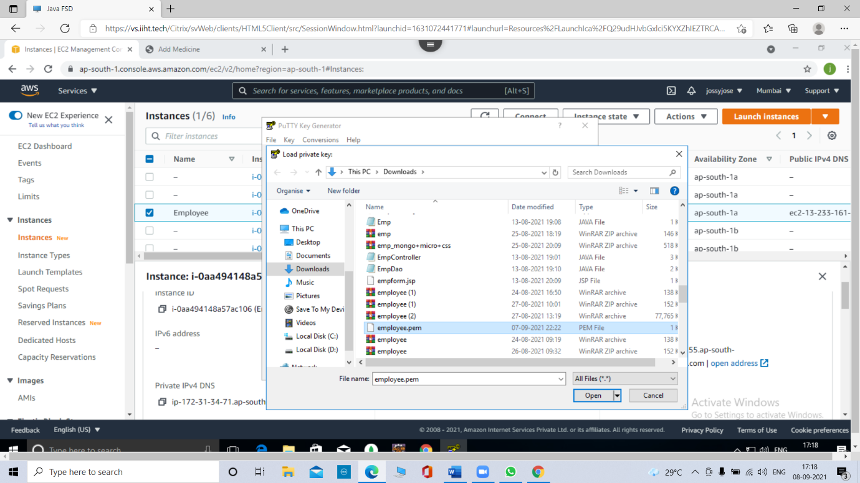

4.3. click on **save private key**

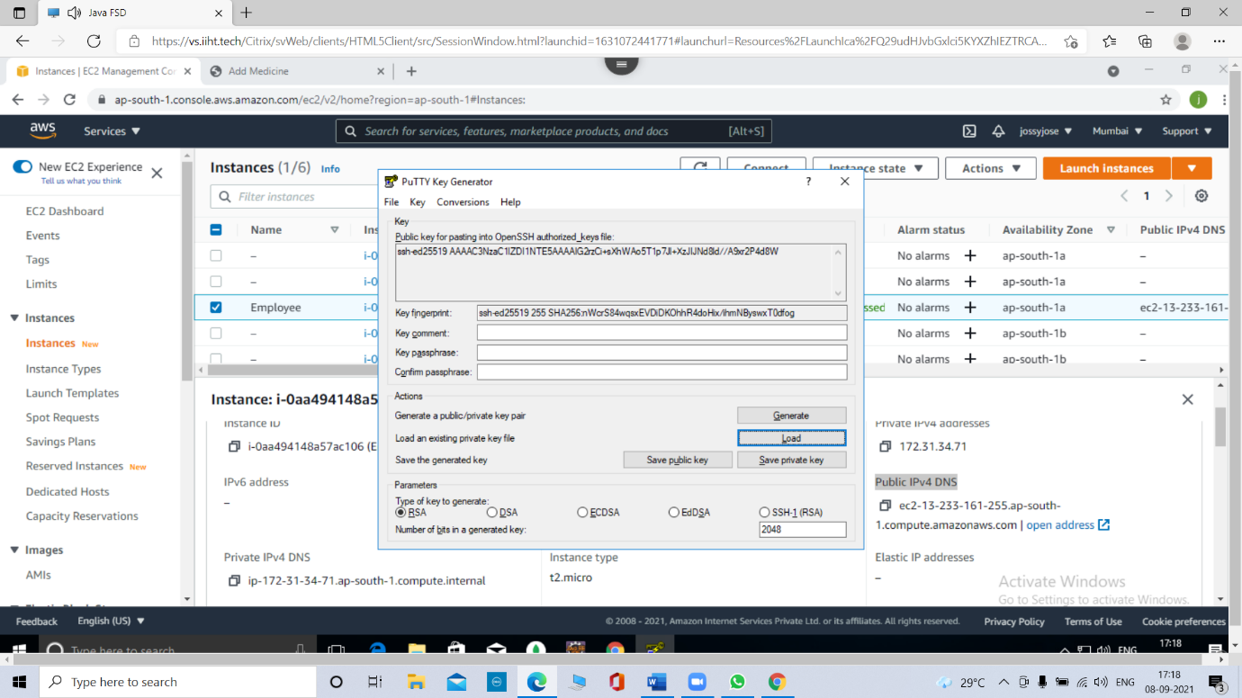

4.4. Give any name to it and **save**.

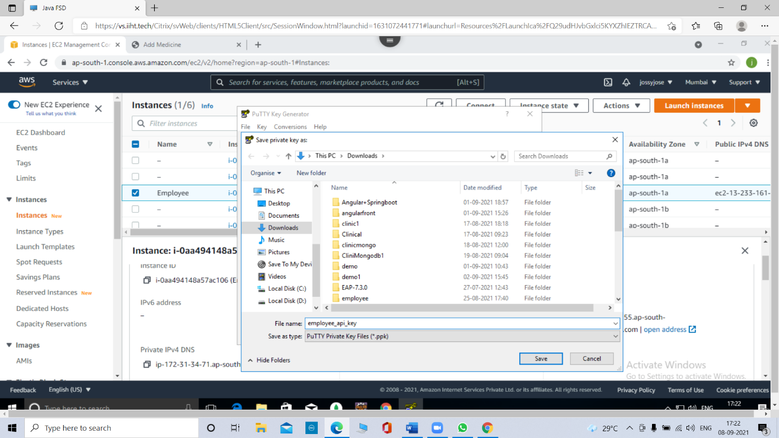

5. Again take **putty** from windows

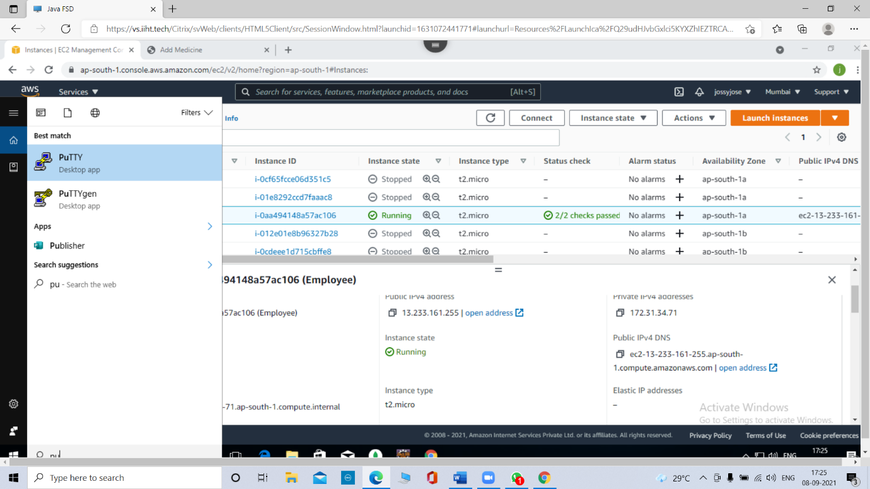

5.1. Copy the **Public IPv4 DNS** from EC2 instance and paste into the **Host Name**

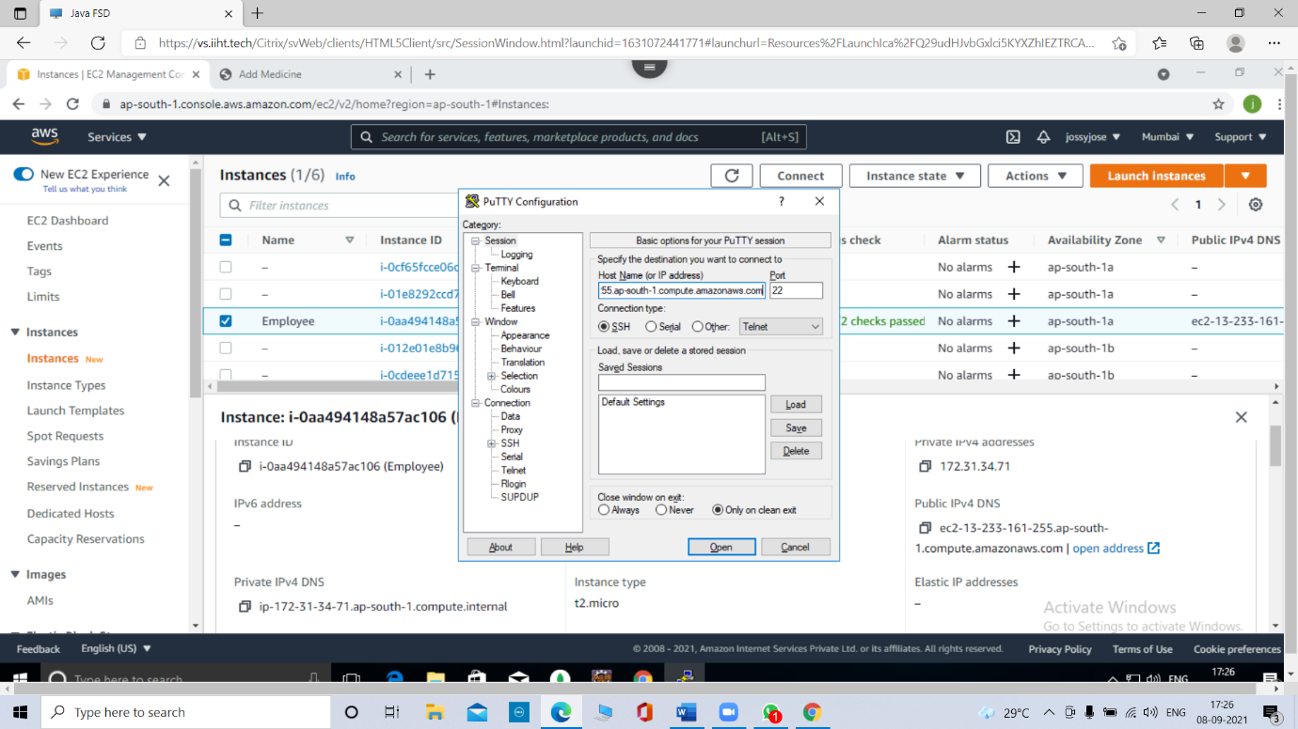

5.2. Click on **Data** and add the **username** as **ubuntu**

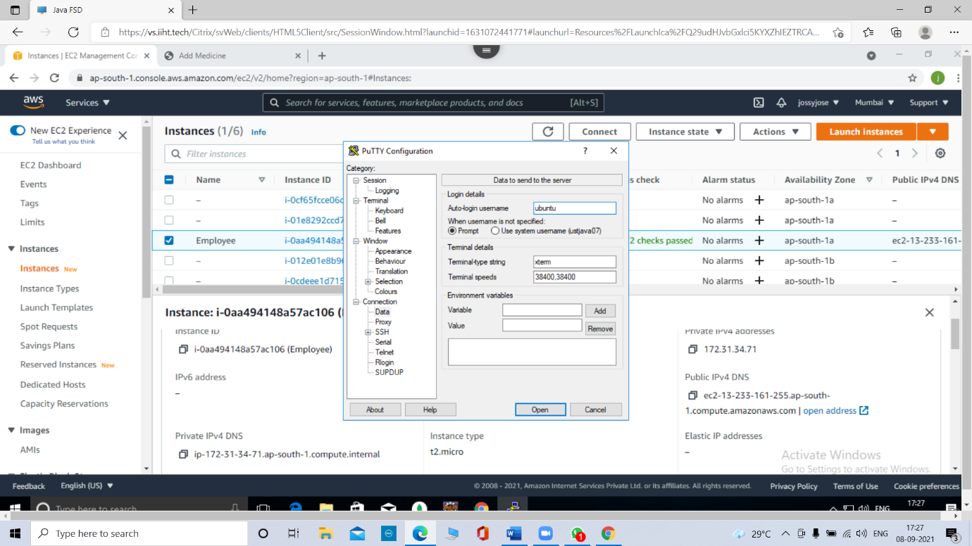

5.3. Click on **SSH**

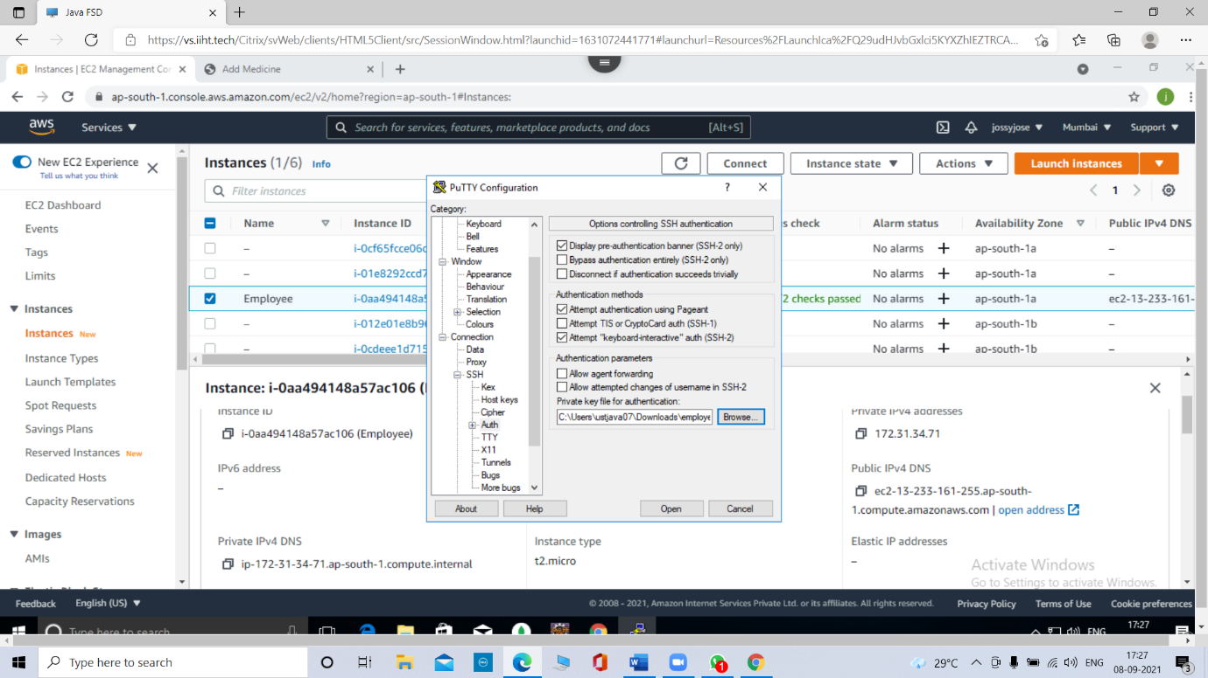

5.4. Click on **Auth** and click on **Browse.** Add **.ppk** file to it. Then click on **open.**



6. Terminal will open like this.

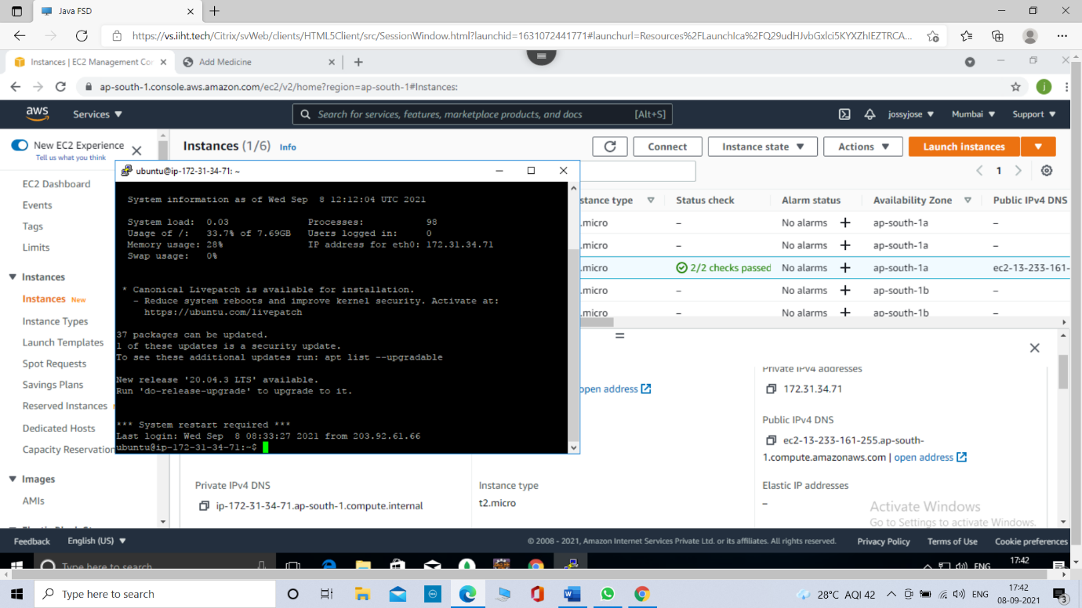

6.1. Type command **sudo -i** for changing into root directory

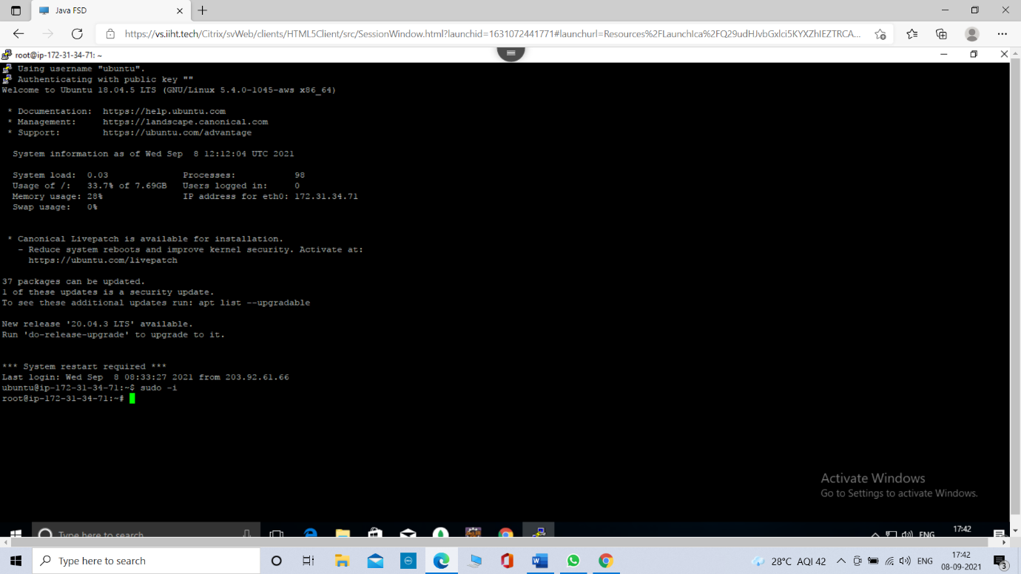

6.2. Go to **s3 bucket** and copy the **object url** of the project jar file. And click on **object actions** button and click on **Make public.**

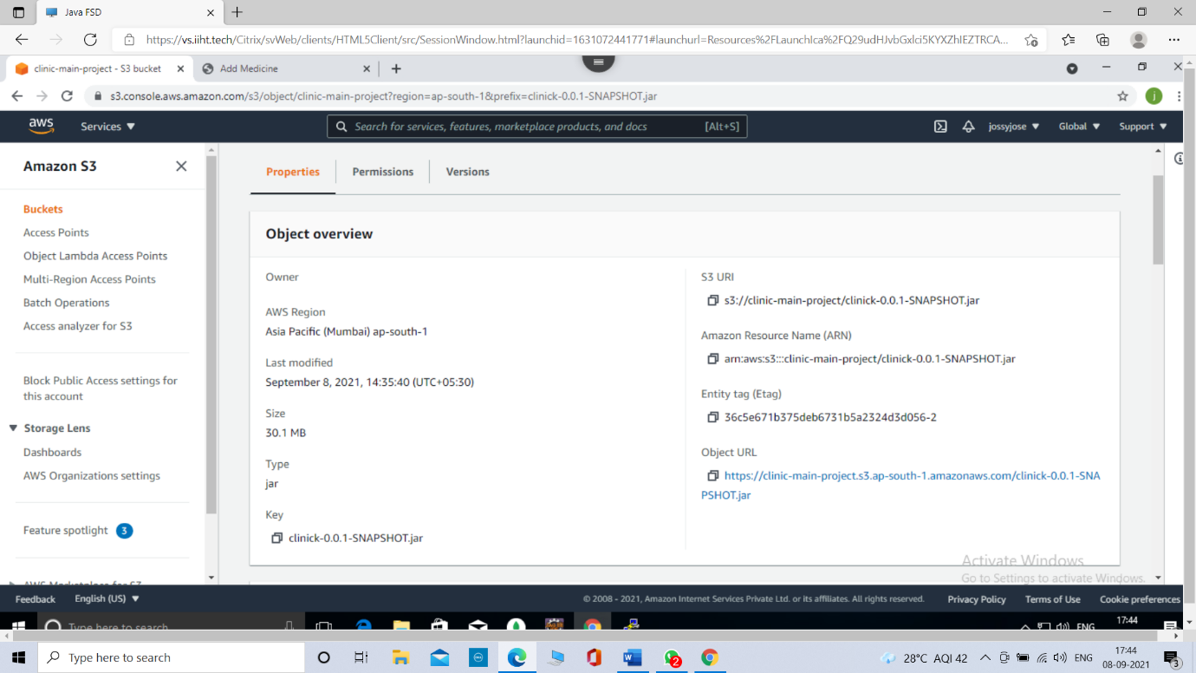

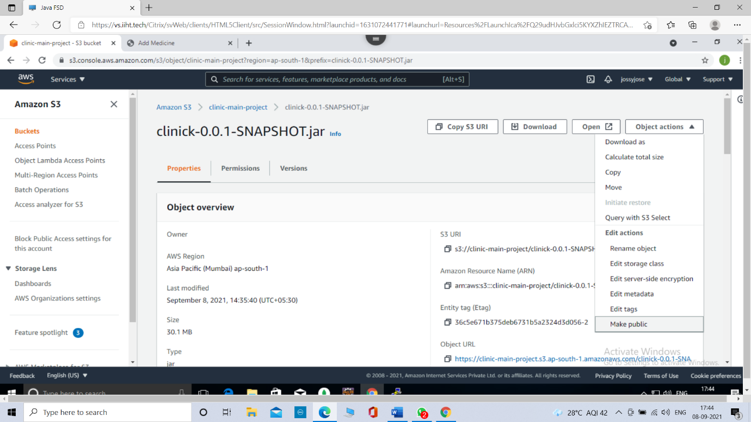

6.3. Return to the terminal and paste the **object ur**l with command **wget** for copy the jar file from s3 bucket to the root directory.

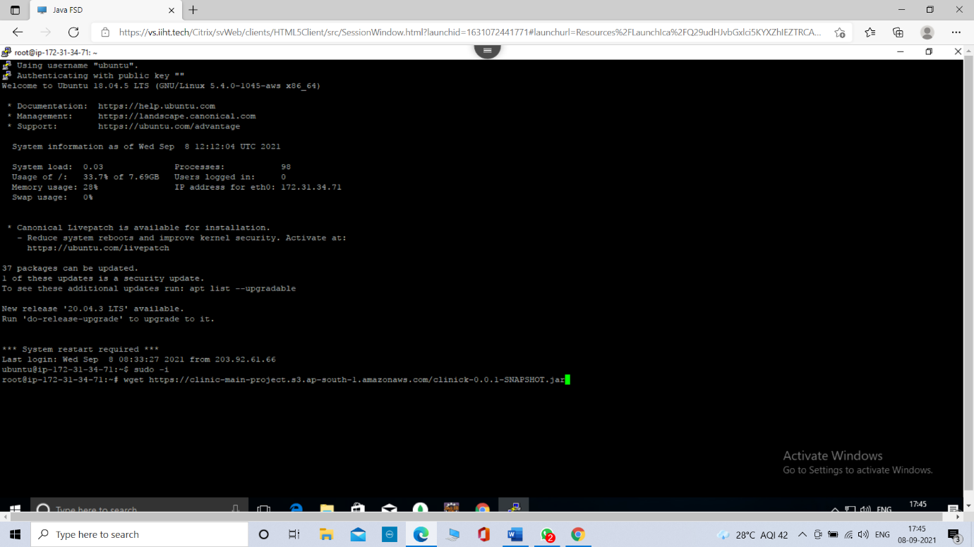

6.4. Type **ls** command for listing the files in root directory and we can see the jar file there.

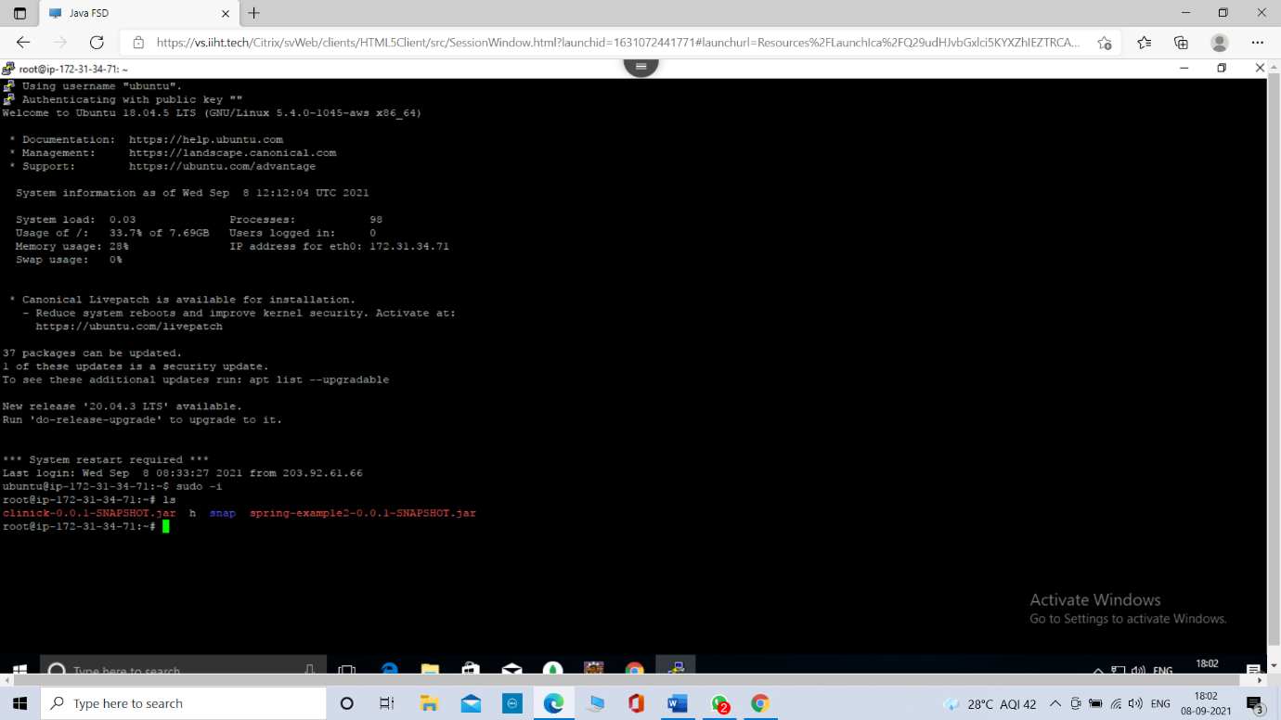

6.5. Start the mongodb by typing command **sudo systemctl start mongod**

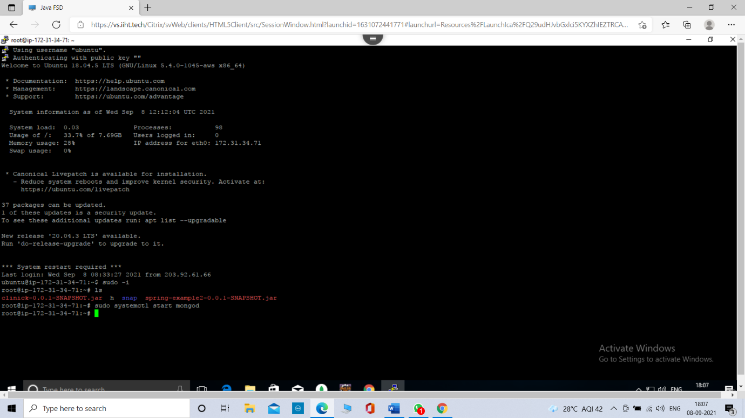

6.6. For running the project type the command **java -jar jar file name**

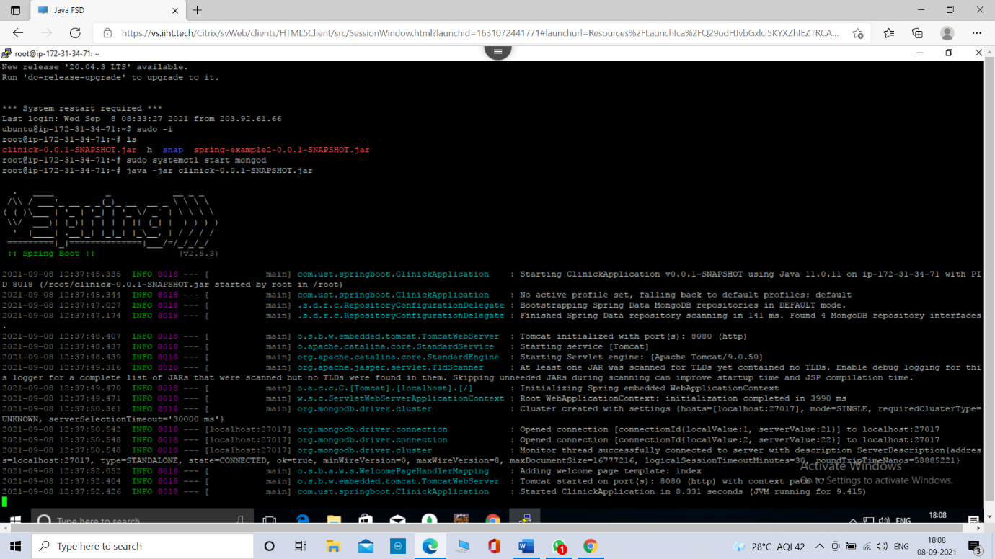

7. Open Browser and Copy the **Public IPv4 DNS url** from EC2 instance and paste into the bar of browser. Then follow with the colon(:) and port number(8080).

